Ismail Chbiki

Individual track

Project Planning

# Introduction

The project planning process that will be applied for the built of this project is agile as an iterative approach to the project management and the software development.

# References

Git Link:

[Chbiki,Ismail I. / Individual Track S3 · GitLab (fhict.nl)](https://git.fhict.nl/I479364/individual-track-s3)

Jira Link: (invitations are sent to all the teachers)

[IT board - Roadmap - Jira (atlassian.net)](https://ismailchbiki.atlassian.net/jira/software/c/projects/IT/boards/5/roadmap)

# Management Tool

The software tool to be used to help the management of the project work flow is *Jira Software*

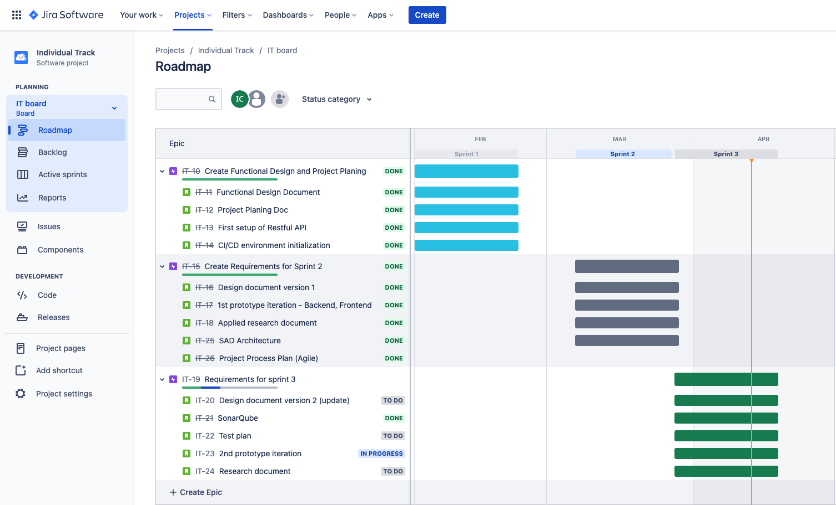

Jira Link